

**Registration form (1 per attendee)**

**First name**:

**Family name**:

**Affiliation name**:

**Full mailing address**:

**E-mail**:

**Phone**:

**Registration fee:**

🞏 PhD student (= with valid ongoing student card): **10 eur** including taxes

🞏 Researcher/Industrial with valid SF2M adhesion: **50 eur** including taxes

🞏 Researcher/Industrial not adherent to SF2M: **70 eur** including taxes

**Name of paying entity** (if different from Affiliation name):

**Right for image sharing**: Do you accept that pictures including yourself taken during the conference be shared in social media or organizing institutes websites?  Yes  No

Particular eating regimen: Please mention if you have specific allergies or regimen

---------------------------------------------------------------------------------------------------------

**Mode of payment requested**:

* Order form (Bon de commande): to the order of “SF2M”
* Bank transfer: SF2M bank account information:

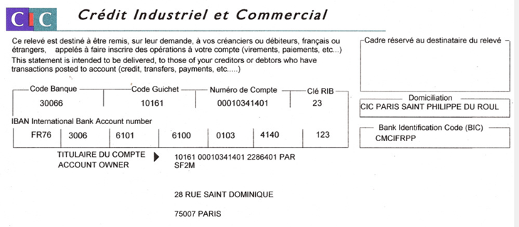

* Credit Card: please contact Katarina Eliot ([secretariat@sf2m.fr](mailto:secretariat@sf2m.fr))